# Day 6 Task: File Permissions and Access Control Lists

1) Create a simple file and do `ls -ltr` to see the details of the files

Each of the three permissions are assigned to three defined categories of users. The categories are:

- owner — The owner of the file or application.

- "chown" is used to change the ownership permission of a file or directory.

- group — The group that owns the file or application.

- "chgrp" is used to change the gropu permission of a file or directory.

- others — All users with access to the system. (outised the users are in a group)

- "chmod" is used to change the other users permissions of a file or directory.

As a task, change the user permissions of the file and note the changes after `ls -ltr`

2) Write an article about File Permissions based on your understanding from the notes.

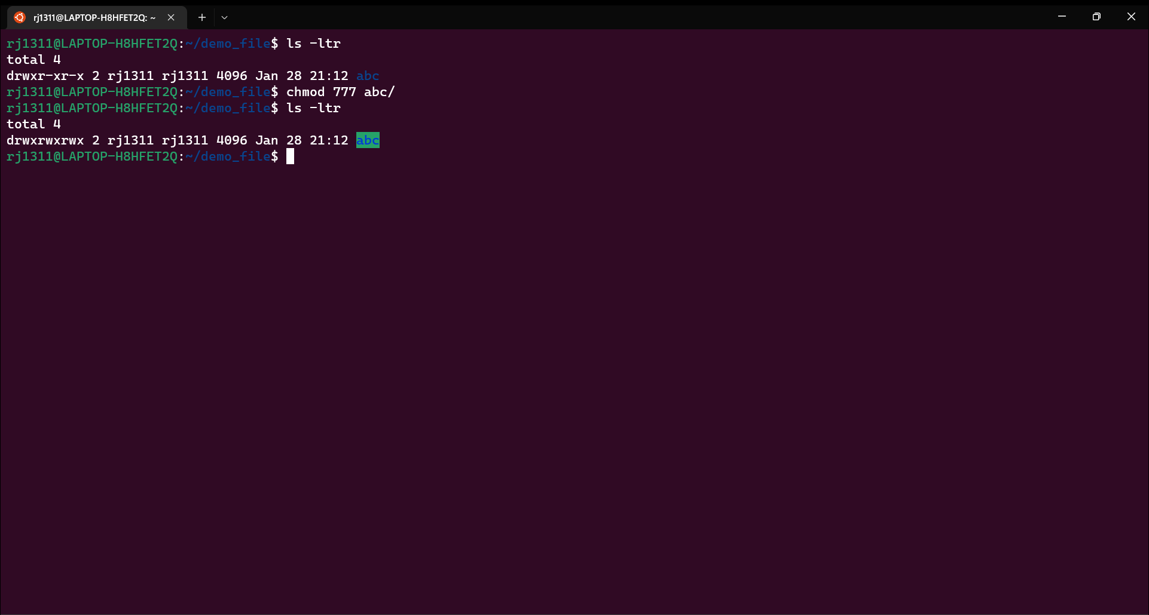

Basically, File Permissions are used to grant read, write and execute permissions to any file

Read (r) : The read permission allows you to open and read the content of a file. But you can't do any editing or modification in the file.

Write (w) : The write permission allows you to edit, remove or rename a file. For instance, if a file is present in a directory, and write permission is set on the file but not on the directory, then you can edit the content of the file but can't remove, or rename it.

Execute (x): In Unix type system, you can't run or execute a program unless execute permission is set.But in Windows, there is no such permission available

A file permission is divided into 3 parts User(u), Group(g) and Others(o) and using the command

***ls -ltr***  we can view the file permissions in a file and it can changed through ***chmod*** command

|  |  |
| --- | --- |
| Number | Permission Type |
| 0 | No permission |
| 1 | Execute |
| 2 | Write |
| 3 | Execute + Write |
| 4 | Read |
| 5 | Read + Execute |
| 6 | Read + Write |
| 7 | All 3 |

If we want to grant all permission to any file , this is the way

**chmod 777 <file name>**

**777 – for user ,group and other**